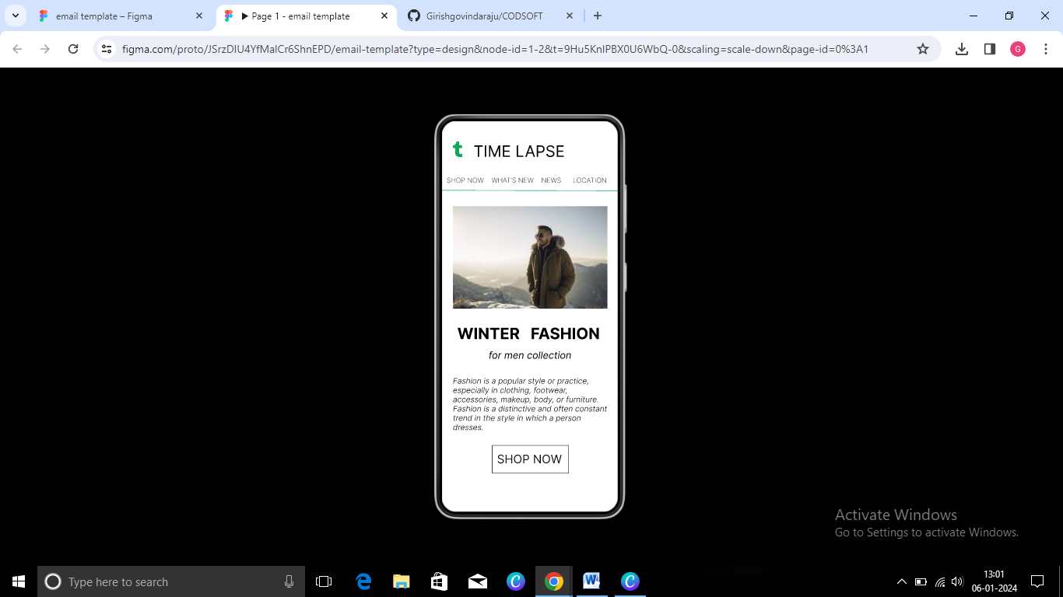

<https://www.figma.com/file/JSrzDIU4YfMalCr6ShnEPD/email-template?type=design&node-id=0%3A1&mode=design&t=9Hu5KnlPBX0U6WbQ-1>